WEEK:3 -SPRING CORE AND MAVEN

Exercise 1: Configuring a Basic Spring Application Scenario:
Your company is developing a web application for managing a library. You need to use the Spring Framework to handle the backend operations.

Steps:
- Set Up a Spring Project:
  - Create a Maven project named LibraryManagement.
  - Add Spring Core dependencies in the pom.xml file.
- Configure the Application Context:
  - Create an XML configuration file named applicationContext.xml in the src/main/resources directory.
  - Define beans for BookService and BookRepository in the XML file.
- Define Service and Repository Classes:
  - Create a package com.library.service and add a class BookService.
  - Create a package com.library.repository and add a class BookRepository.
- Run the Application:
  - Create a main class to load the Spring context and test the configuration.

SOLUTION

pom.xml
<project xmlns="http://maven.apache.org/POM/4.0.0" xmlns:xsi="http://www.w3.org/2001/XMLSchema-instance"

xsi:schemaLocation="http://maven.apache.org/POM/4.0.0 http://maven.apache.org/xsd/maven-4.0.0.xsd">
<modelVersion>4.0.0</modelVersion>
<groupId>com.library</groupId>
<artifactId>LibraryManagement</artifactId>
<packaging>jar</packaging>
<version>1.0-SNAPSHOT</version>
<name>LibraryManagement</name>
<dependencies>
<dependency>
<groupId>org.springframework</groupId>
<artifactId>spring-context</artifactId>
<version>5.3.36</version>
</dependency>
<dependency>
<groupId>junit</groupId>
<artifactId>junit</artifactId>
<version>4.13.2</version>
<scope>test</scope>
</dependency>
</dependencies>

<build>
<plugins>
<plugin>
<groupId>org.codehaus.mojo</groupId>
<artifactId>exec-maven-plugin</artifactId>
<version>3.1.0</version>
<configuration>
<mainClass>com.library.main.MainApp</mainClass>
</configuration>
</plugin>
</plugins>
</build>
</project>

MainApp.java
package com.library.main;
import com.library.service.BookService;
import org.springframework.context.ApplicationContext;
import org.springframework.context.support.ClassPathXmlApplicationContext;

public class MainApp {
public static void main(String[] args) { ApplicationContext context = new
ClassPathXmlApplicationContext("applicationContext.xml");

BookService bookService = (BookService) context.getBean("bookService"); bookService.addBook("Clean Code");
}}

BookService.java
package com.library.service;
import com.library.repository.BookRepository; public class BookService {
private BookRepository bookRepository;

public void setBookRepository(BookRepository bookRepository) { this.bookRepository = bookRepository;
}

public void addBook(String bookName) { System.out.println("Adding book: " + bookName); bookRepository.saveBook(bookName);
}
}

BookRepository.java
package com.library.repository; public class BookRepository {
public void saveBook(String bookName) {
System.out.println("Book \"" + bookName + "\" saved to the database.");
}
}

applicationContext.xml
<?xml version="1.0" encoding="UTF-8"?>
<beans xmlns="http://www.springframework.org/schema/beans"

xmlns:xsi="http://www.w3.org/2001/XMLSchema-instance" xsi:schemaLocation=" http://www.springframework.org/schema/beans http://www.springframework.org/schema/beans/spring-beans.xsd">

<bean id="bookRepository" class="com.library.repository.BookRepository" />
<bean id="bookService" class="com.library.service.BookService">
<property name="bookRepository" ref="bookRepository" />
</bean>

</beans>

AppTest.java
package com.library; import org.junit.Test;
public class AppTest { @Test
public void testApp() { System.out.println("Test executed.");
}
}

OUTPUT
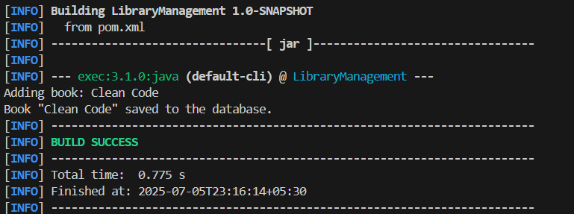

Exercise 2: Implementing Dependency Injection Scenario:
In the library management application, you need to manage the dependencies between the BookService and BookRepository classes using Spring's IoC and DI.

Steps:
- Modify the XML Configuration:
  - Update applicationContext.xml to wire BookRepository into BookService.
- Update the BookService Class:
  - Ensure that BookService class has a setter method for BookRepository.
- Test the Configuration:
Run the LibraryManagementApplication main class to verify the dependency injection

SOLUTION
Use Spring’s Inversion of Control (IoC) to inject the BookRepository into BookService using an XML file (applicationContext.xml).

applicationContext.xml

<?xml version="1.0" encoding="UTF-8"?>
<beans xmlns="http://www.springframework.org/schema/beans" xmlns:xsi="http://www.w3.org/2001/XMLSchema-instance" xsi:schemaLocation=" http://www.springframework.org/schema/beans http://www.springframework.org/schema/beans/spring-beans.xsd">

<bean id="bookRepository" class="com.library.repository.BookRepository"/>

<bean id="bookService" class="com.library.service.BookService">
<property name="bookRepository" ref="bookRepository"/>
</bean>

</beans>

BookService.java
package com.library.service;
import com.library.repository.BookRepository; public class BookService {
private BookRepository bookRepository;

public void setBookRepository(BookRepository bookRepository) { this.bookRepository = bookRepository;
}

public void addBook(String title) { System.out.println("Adding book: " + title); bookRepository.save(title);
}
}

MainApp.java
package com.library;

import com.library.service.BookService;
import org.springframework.context.ApplicationContext;
import org.springframework.context.support.ClassPathXmlApplicationContext; public class MainApp {

public static void main(String[] args) { ApplicationContext context = new
ClassPathXmlApplicationContext("applicationContext.xml");

BookService bookService = (BookService) context.getBean("bookService"); bookService.addBook("Clean Code");
}
}

OUTPUT
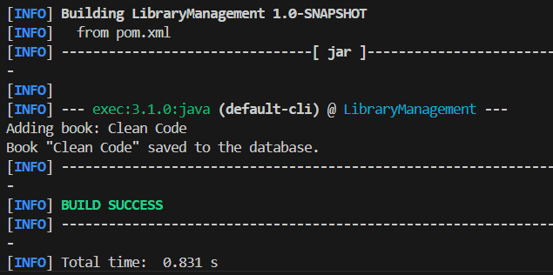

Exercise 4: Creating and Configuring a Maven Project Scenario:
You need to set up a new Maven project for the library management application and add Spring dependencies.

Steps:
- Create a New Maven Project:
  - Create a new Maven project named LibraryManagement.
- Add Spring Dependencies in pom.xml:

  - Include dependencies for Spring Context, Spring AOP, and Spring WebMVC.
- Configure Maven Plugins:
  - Configure the Maven Compiler Plugin for Java version 1.8 in the pom.xml file.

SOLUTION

pom.xml
<project xmlns="http://maven.apache.org/POM/4.0.0" xmlns:xsi="http://www.w3.org/2001/XMLSchema-instance" xsi:schemaLocation="http://maven.apache.org/POM/4.0.0
http://maven.apache.org/xsd/maven-4.0.0.xsd">

<modelVersion>4.0.0</modelVersion>
<groupId>com.library</groupId>
<artifactId>LibraryManagement</artifactId>
<version>1.0-SNAPSHOT</version>

<dependencies>
<!-- Spring Context -->
<dependency>
<groupId>org.springframework</groupId>
<artifactId>spring-context</artifactId>
<version>5.3.33</version>
</dependency>

<!-- Spring AOP -->
<dependency>
<groupId>org.springframework</groupId>
<artifactId>spring-aop</artifactId>
<version>5.3.33</version>
</dependency>

<!-- Spring WebMVC -->

<dependency>
<groupId>org.springframework</groupId>
<artifactId>spring-webmvc</artifactId>
<version>5.3.33</version>
</dependency>

<!-- JUnit -->
<dependency>
<groupId>junit</groupId>
<artifactId>junit</artifactId>
<version>4.13.2</version>
<scope>test</scope>
</dependency>
</dependencies>

<build>
<plugins>
<!-- Maven Compiler Plugin -->
<plugin>
<groupId>org.apache.maven.plugins</groupId>
<artifactId>maven-compiler-plugin</artifactId>
<version>3.8.1</version>
<configuration>
<source>1.8</source>
<target>1.8</target>
</configuration>
</plugin>

<!-- Exec Plugin to run main class -->
<plugin>
<groupId>org.codehaus.mojo</groupId>
<artifactId>exec-maven-plugin</artifactId>
<version>3.1.0</version>
<executions>
<execution>

<goals>
<goal>java</goal>
</goals>
</execution>
</executions>
</plugin>
</plugins>
</build>

</project>

MainApp.java
package com.library.main;

import com.library.service.BookService;
import org.springframework.context.ApplicationContext;
import org.springframework.context.support.ClassPathXmlApplicationContext;

public class MainApp {
public static void main(String[] args) { ApplicationContext context = new
ClassPathXmlApplicationContext("applicationContext.xml");

BookService bookService = (BookService) context.getBean("bookService"); bookService.addBook("Clean Code");
}
}

BookService.java
package com.library.service;
import com.library.repository.BookRepository; public class BookService {
private BookRepository bookRepository;

public void setBookRepository(BookRepository bookRepository) { this.bookRepository = bookRepository;
}

public void addBook(String bookName) { System.out.println("Adding book: " + bookName); bookRepository.saveBook(bookName);
}
}

BookRepository.java
package com.library.repository;

public class BookRepository {
public void saveBook(String bookName) {
System.out.println("Book \"" + bookName + "\" saved to the database.");
}
}

applicationContext.xml
<?xml version="1.0" encoding="UTF-8"?>
<beans xmlns="http://www.springframework.org/schema/beans" xmlns:xsi="http://www.w3.org/2001/XMLSchema-instance" xsi:schemaLocation=" http://www.springframework.org/schema/beans http://www.springframework.org/schema/beans/spring-beans.xsd">

<bean id="bookRepository" class="com.library.repository.BookRepository" />
<bean id="bookService" class="com.library.service.BookService">
<property name="bookRepository" ref="bookRepository" />
</bean>

</beans>

OUTPUT
